* Abdul Rafay Javed
* Bese-4B
* Reg# 07504

Assignment#1

# **Description:**

In this assignment I was given a task to develop an interactive alphabet learning app that also have a quiz. I was restricted to use only CSS3 and HTML5 and also to use only 24 images. I have performed the task under the given restrictions and developed an alphabet learning app using only CSS3 and HTML5. I overcame the restriction of using only 24 images by drawing two pictures using CSS. I have drawn a moon and a star. My source code have two html files one that contains tutorial that displays a picture of an object that begins with the corresponding alphabet. The other html contains a quiz in which you are shown an image of an object and you have to choose the correct alphabet. I have used multiple div to make the app more interactive for the children. I have used href,target to switch between html pages and to change question and look at other alphabets. I have taken a little help from W3schools and CSS tricks. Tool and functionalities used by me are as follows

## Tools used:

* HTML5
* CSS3

## Functionalities used:

* Img
* Div
* Animation
* Translate
* Href
* Target
* CSS styling
* Unordered lists

## Screenshots:

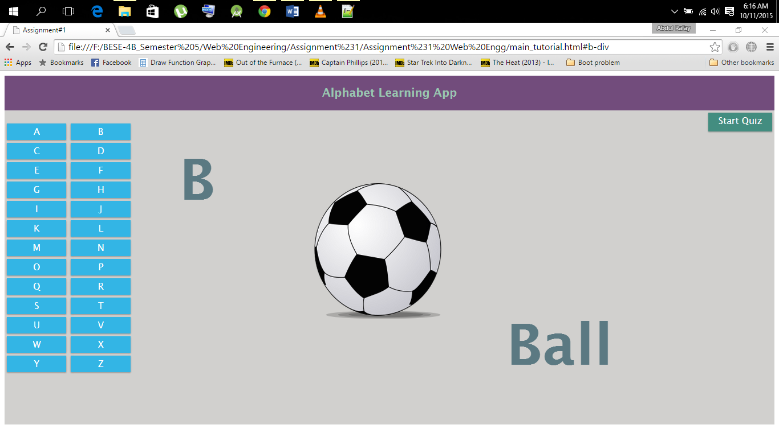

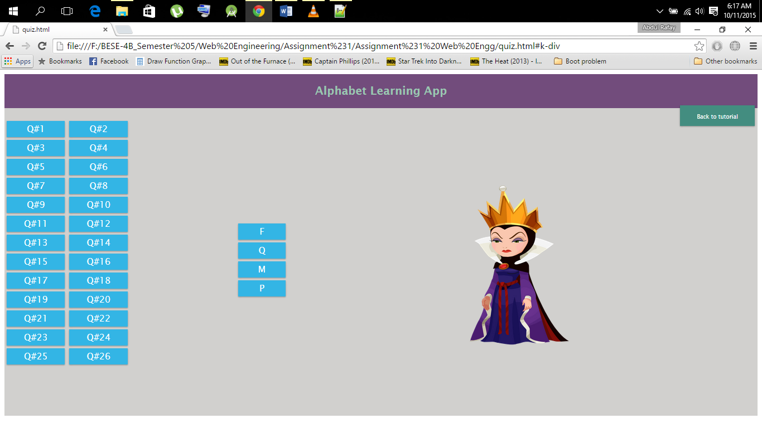

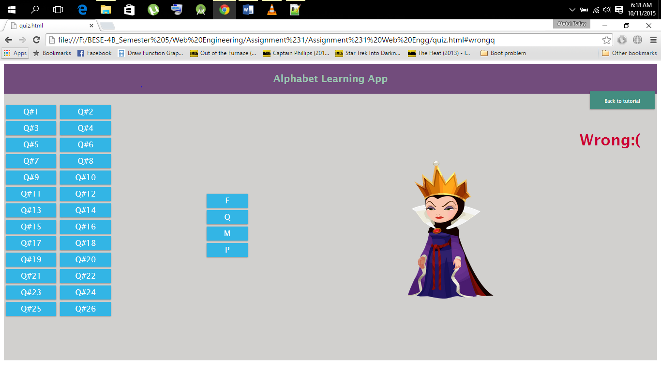

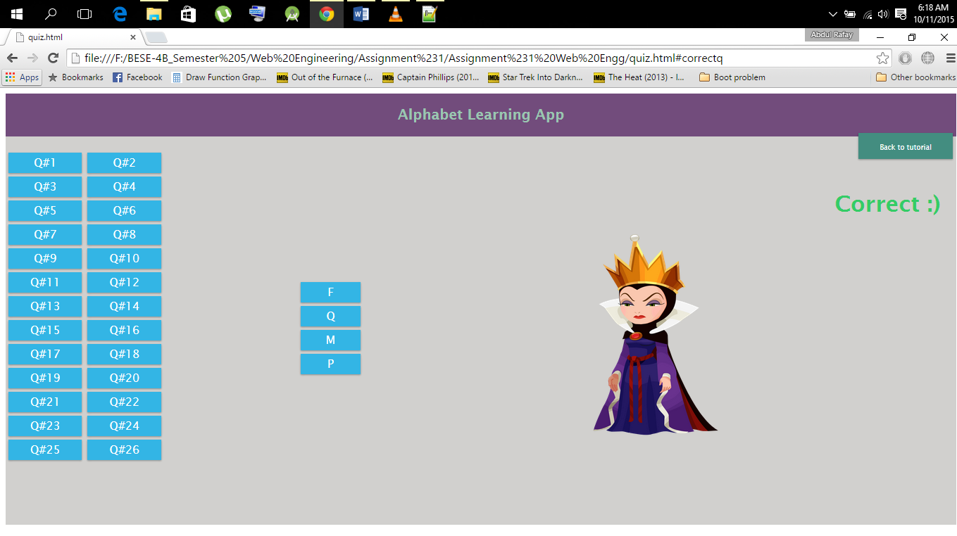

## Link of github file is as follows

<https://github.com/RafayJaved/Web_Engg_Assignment-1>